Version 1.2.0



Group 12

ibm Skillsbuild

User manual

Contents

1. **Getting Started**
   1. 1.1 Creating an Account
   2. 1.2 Navigating the Dashboard
   3. 1.3 Using the Dashboard to submit a review
2. **Earning Points and Rewards**
   1. 2.1 Completing Courses and Daily Rewards
   2. 2.2 Levelling Up
3. **Leaderboards and Competition**
   1. 3.1 How the Leaderboard Works
4. **Your User Profile**
   1. 4.1 Viewing Progress
   2. 4.2 Customizing Settings
5. **Frequently Asked Questions (FAQs)**
   1. 5.1 General FAQs
   2. 5.2 Account and Login FAQs
   3. 5.3 Course FAQs
   4. 5.4 Points, Rewards, and Levels FAQs
   5. 5.5 Leaderboards FAQs
   6. 5.6 Technical FAQs

**Section 1: Getting Started**

1.1 Creating an Account

To create an account with CourseXP, simply navigate to the home page at:

http:localhost:8080/

From here, there are two ways to navigate to the registration page. Either navigate to it via the ***‘Get Started’*** button, or via the ***‘Register’*** button in the navigation bar at the top of the screen. Both options are highlighted below:

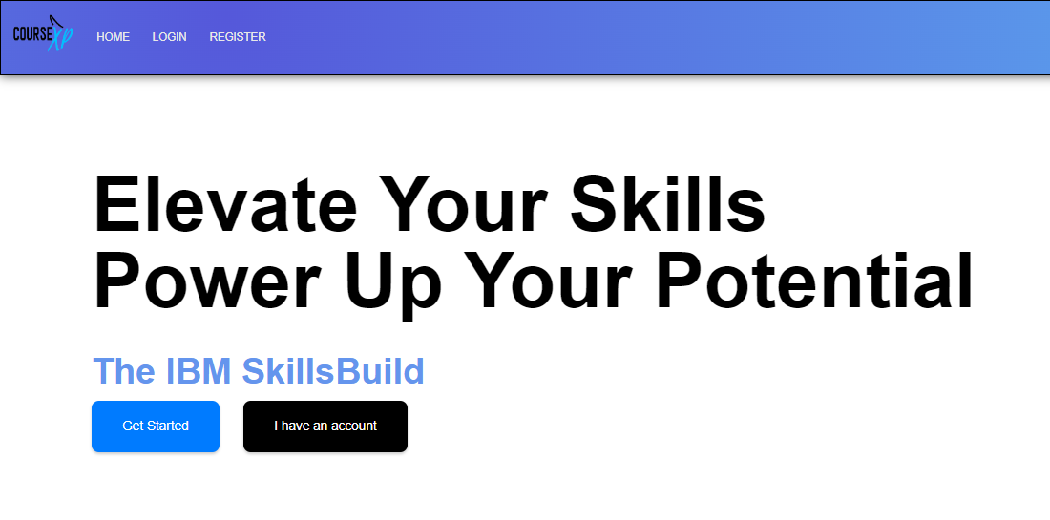

You will be greeted with a page like the one below:

From here enter your credentials to your new account, and once complete, click the ***‘Register’*** button at the bottom of the page. If you have navigated to this page in error, simply click the ***‘Sign In'*** button at the very bottom of the page. Our logo ***‘CourseXP’*** is also clickable and will redirect you to the home page.

**Congratulations, if you have followed the instructions above, you have just registered an account with us!**

*To log in, simply navigate to the login page, links for which have been outlined in the instructions above.*

1.2 Navigating the Dashboard

*Prerequisites to this section involve having registered an account with us and having logged in with those credentials.*

You’re ready to navigate our app. After logging in, you should have been greeted with your dashboard page, showing all courses you can take.

When you start a course, you’ll see them on this page too. Below is a general outline of what you can currently see:

Button to open this menu

Logout button

All available courses to you

Link to this page

The button to start the course

Link to the player leaderboard *(see section 3.1)*



After starting a course, you’ll see a menu open below the available courses appear, as shown below. This menu will allow you to pick up where you left off with your courses, so you don’t have to complete them all in one go. It will also allow you to mark a course as completed, adding that course to your list of completed courses, and adding your earned points for that course to the global leaderboard *(see section 3.1)*

1.3 Using the dashboard to submit a review

After a user has finished a course, they are able to click on the ‘Finish’ button *(see 1.2)*. After clicking on this, the screen should look like this:

This modal prompts the user to give the course a rating between 1-5, using the arrows in the first box and a written review in the second box.

Once the user clicks on the submit feedback button in black, the review will be stored into our database provided it satisfies the conditions of our error handling – cannot be empty.

**Section 2: Earning Points and Rewards**

2.1 Completing Courses

Upon completion of a course, you’ll be given points, alongside any badges you may have picked up along the way (you can view these in your profile). Points contribute towards your global leaderboard position.

A course that takes more time, or more skill to complete, will result in a higher point reward for completing it. Points earned can be boosted by our ***Daily Rewards*** system if the effect is active when the course is ended.

2.2 Daily Spin Wheel

Daily rewards, as the name suggests, are rewards that can be randomly won daily. The effects of the reward apply to all courses completed in that timeframe. Multipliers for points are won randomly on the Daily Reward Spin Wheel, ranging from 1.5x, 2x, and 3x, as shown below:

Each day, you will be prompted to spin the wheel, and win whatever multiplier the wheel lands on. It will then effect the points you earn for completing the course, which is shown by the levelling bar under the header *(see section 2.3).*

2.3 Levelling Up

This system visually represents the progress you have made by completing courses. Every time you complete a course, the progress bar will fill up accordingly, and will multiply by the amount you achieved by spinning the wheel for that day. Once the bar fills up, you will receive a pop up that you have levelled up to the next level. Not only that, but for you to keep track of your level, not only the progress, next to the bar is the current level that you are on, as shown below:

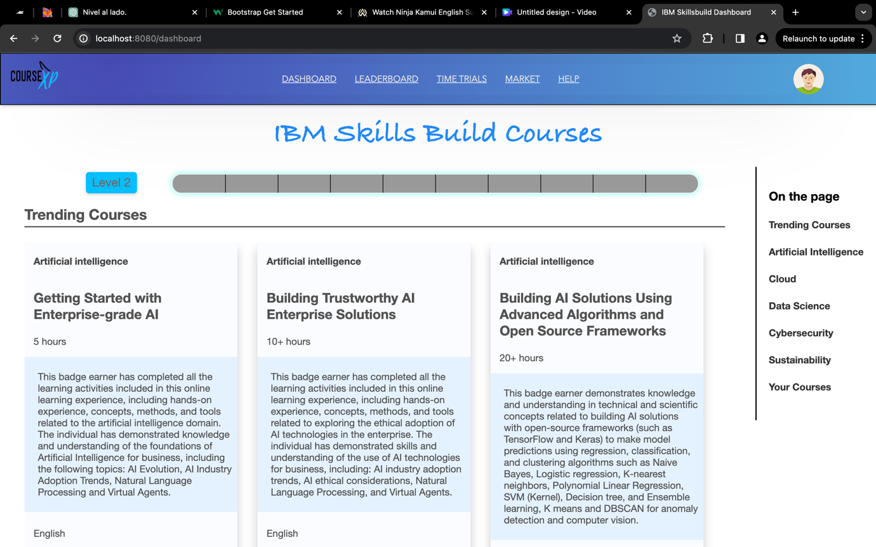

Your current level

Progress bar that fills up as you complete courses

**Section 3: Leaderboards and Competitions**

3.1 How the Leaderboard Works

The Global Leaderboard is a collective of everybody competing to have the highest level of attainment. If somebody is higher on the leaderboard, they are either completing more courses, or are completing more complex courses.

It can be navigated to, either by typing in the URL:  
To create an account with CourseXP, simply navigate to the home page at:

http:localhost:8080/leaderboard

Or simply by clicking the helpful link in the navigation bar at the top of the page:  


There are rewards for the highest level of players on the leaderboard, such as unique badges, and other mystery prizes.

Once a player starts a course, they automatically start competing on the Global Leaderboard, and the only way is up.

**Section 4: Your User Profile**

**Section 5: Frequently Asked Questions**

**5.1 General FAQs**

**What is the purpose of this app?**

**How does the gamification aspect work?**

**Is there a cost to use the app?**

**Do I need an IBM SkillsBuild account to use this?**

**What devices and browsers are compatible with the app?**

**5.2 Account and Login FAQs**

**How do I create an account?**

**Can I use my university email to register?**

**I forgot my password. How do I reset it?**

**Can I link my existing IBM SkillsBuild account?**

**How do I update my profile information?**

**5.3 Course FAQs**

**How do I find and enrol in IBM SkillsBuild courses?**

**How do I start a challenge?**

**What's the difference between a course and a challenge?**

**Can I track my progress on courses?**

**Are there deadlines for completing courses or challenges?**

**5.4 Points, Rewards, and Levels FAQs**

**How do I earn points?**

**What kinds of rewards are available?**

**How does the levelling system work?**

**Where can I see my current points and level?**

**Do points or rewards expire?**

**5.5 Leaderboards FAQs**

**How do I view the leaderboards?**

**Are there different leaderboard categories?**

**How often are leaderboards updated?**

**Can I compete with just my friends or classmates?**

**5.6 Technical FAQs**

**A course isn't loading. What should I do?**

**My points aren't updating correctly. How do I fix this?**

**Who do I contact if I have technical issues?**